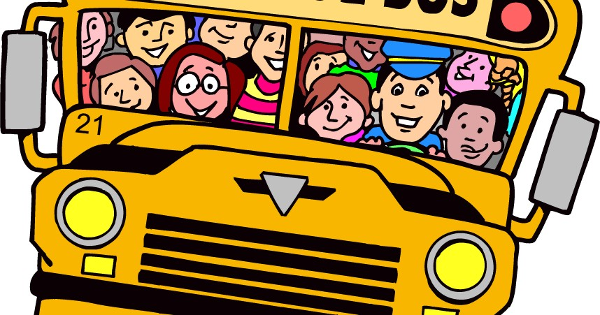

2026-2027 Bus Transportation
ONLINE REGISTRATION INSTRUCTIONS
MYSCHOOLBUCKS
All Registrations must be completed using MySchoolBucks. If assistance is needed MySchoolBucks can be reached at 855-832-5226. Please follow these instructions to use the new Registration System:

- Click on MySchoolBucks Login Link and Select SIGN IN TODAY.
- Create a username/password and make sure to select MA for your state and Chelmsford Public Schools as your district.
- Go Back to MySchoolBucks Login Link and Enter your Username and Password. You will be asked a method to have a verification code delivered to your email or cell phone in order to login.
- Enter the verification code and you will be directed to the dashboard for Chelmsford Public Schools Dashboard.
- On the left-hand side select ADD STUDENT.
- Select your Student and enter the necessary information. You will need to enter their Date of Birth.
- Once you have selected your student, click on STORE and then BROWSE ALL PRODUCTS.
- Click on TRANSPORTATION and Select from the drop-down menu your Student and Payment Method
  - Bus Pass Early Bird
  - K-6 Over 2 Miles (This selection is limited to students in grades K-6 who live over 2 miles from the school)
  - Seeking Financial Assistance (This selection also requires approval for the free and reduced lunch program and sending the award letter to the transportation department)
- Add to Cart, if you have more than one Student please REPEAT for all Students by adding them to your Cart.
- Please note YOU MUST add all students to your cart to get the discounted pricing (FAMILY CAP) before checking out.
- GO TO CART and PURCHASE BUS PASS EVEN IF YOU OWE ZERO DOLLARS. YOU MUST CHECK OUT TO COMPLETE YOUR REGISTRATION. IF YOU DO NOT CHECK OUT AND SUBMIT YOU ARE NOT REGISTERED.

If you have any questions, please reach out to our Transportation Department at 978-251-5100 x6942 or brekalisp@chelmsford.k12.ma.us

