TIP SHEET

How To Understand And Handle Cyberbullying
When a kid of any age, up to 18 is threatened, humiliated, harassed, or humiliated via use of technology --- this is Cyberbullying. Yet many college students are being cyberbullied as well.
Depending on their ages, up to 43% of students are being digitally harassed online. While most call it cyberbullying, it's important to understand that not all of these kids and teens are being bullied online, but they are being digitally harassed in one form or another. Either way it's not fun!
This social online nuisance is used through e-mail, cell phones, instant messaging, Web sites, online personal polling Web sites. It is done by kids deliberately and repeatedly and is used by an individual or group with the intention of harming other kids and teens.
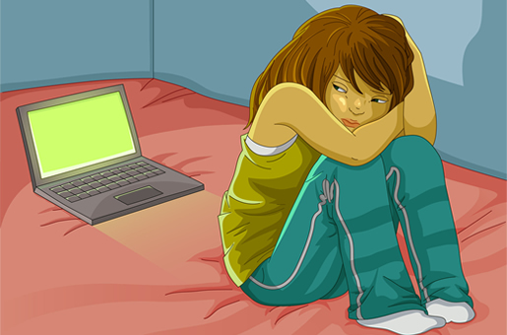
- Kids use technology to talk to their friends and make new ones. While most kids use the Internet responsibly, others are using all of this technology to harass online!
- Kids should be taught that if they wouldn't say something to someone's face, they shouldn't say it to them online, through texting, or posting in any other way.
- Digital Harassment is the perfect way for the online aggressors to remain anonymous. So anonymous, there is no fear of punishment because they don't have to come face to face with their victim(s.)
- The very first thing parents must do is learn the Internet. In other words …Speak the lingo and know the game!!
If you don’t how will you help your children? If you do not work on a computer and the Internet regularly, there are libraries, schools, YMCAs and neighborhood associations who offer this instruction.
- The second thing you must to is to communicate with your kids and teens. Let them know that it’s okay to come to you if they are being cyberbullied. Encourage them to tell you immediately if they are being digitally harassed, cyberbullied, cyberstalked or if they’ve been approached by a predator. Tell them you won’t be angry about anything. You just want to help them.
- Be sure to keep your home computer(s) out in the open, such as a family room or kitchen.
- Encourage your child to alert you if they are aware of others who may be the victims of similar behavior.
- Explain that cyberbullying is harmful and unacceptable. Discuss appropriate online behavior and make it clear that there will be consequences for inappropriate behavior.
- Although it’s important to install parental control filtering software, it’s just as important for you to monitor your child’s computer. You want to respect your children’s privacy yet, your child’s safety may override these privacy concerns. Tell your child that you are not spying on them but you may review their online communications if you think there is reason for concern.
Recent studies found that:
•18% of students in grades 6-8 said they had been cyberbullied at least once in the last couple of months; and 6% said it had happened to them 2 or more times.
•11% of students in grades 6-8 said they had cyberbullied another person at least once in the last couple of months, and 2% said they had done it two or more times.
•19% of regular Internet users between the ages of 10 and 17 reported being involved in online aggression; 15% had been aggressors, and 7% had been targets (3% were both aggressors and targets)
•17% of 6-11 year-olds and 36% of 12-17-year-olds reported that someone said threatening or embarrassing things about them through email, instant messages, web sites, chat rooms, or text messages.
•Cyberbullying has increased in recent years. In nationally representative surveys of 10-17 year-olds, twice as many children and youth indicated that they had been victims and perpetrators of online harassment.
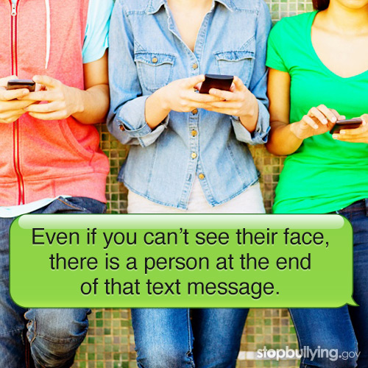
Who Are The Victims and Perpetrators of Cyberbullying?
In a recent study of students in grades 6-8
•Girls were about twice as likely as boys to be victims and perpetrators of cyber bullying.
•Of those students who had been cyberbullied relatively frequently (at least twice in the last couple of months):
•62% said that they had been cyberbullied by another student at school, and 46% had been cyberbullied by a friend.
•55% didn't know who had cyberbullied them.
•Of those students who admitted cyberbullying others relatively frequently:
•60% had cyberbullied another student at school, and 56% had cyberbullied a friend.
Kids And Teens Bully Online In Various Ways:
Social Media
Most social media sites have a minimum age requirement of 13. Parents should pay special attention to this. YikYak requires users to 17 and older.
There are social media sites for younger children such as Disney, Club Penguin, YourSphere, Sweety High, KidzWorld and others.
- Facebook, Twitter, Instagram, Snapchat, Tumblr, Vine Google+, Kik, Yik Yak, Wanelo, Ask.fm, Whisper, Ooovoo, Yo., WhatsApp and Omegle
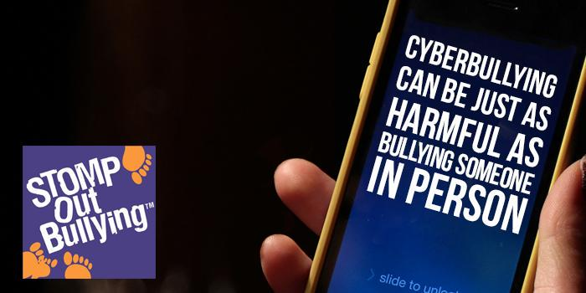Teens' favorite digital hangouts change from time to time and currently many teens are shying away from Facebook, but the fact is that one-stop shopping for all social-networking needs are over. Teens divide their attention between a whole host of apps and tools that let them write, share, video-chat, and even shop for the latest trends.
- Facebook Messenger is an app that lets Facebook users text, voice message, send video or photos instantly, or call contacts from their mobile devices. The text-like messages, voice messages, and phone calls (to other Facebook users) are free, even internationally. Users' phones give a sound or light notification when they get a message, and they can see when someone else has viewed the messages they send. Notifications can be turned off, but the user remains logged in. Users can send messages to individuals privately or to groups that they've created. Unless the location notification is turned off, anyone who receives a message can see on a map where the sender is.
- YouTube can pose a challenge because anyone can create them. They pop up out of nowhere, don't follow program schedules, and they're cast out among thousands of other videos. YouTube has a huge impact on kids and you'll learn a lot about what they are tuning into. Parents should turn on the safety mode. Most kids find out about new videos either from their friends or by clicking on the related videos (which may not always be appropriate). But YouTube offers several ways to hone in on quality content. Visit YouTube Nation for curated content in a variety of categories. Read about YouTube news on YouTube’s company blog, and find out what's trending all over the country on the Map and the Dashboard. 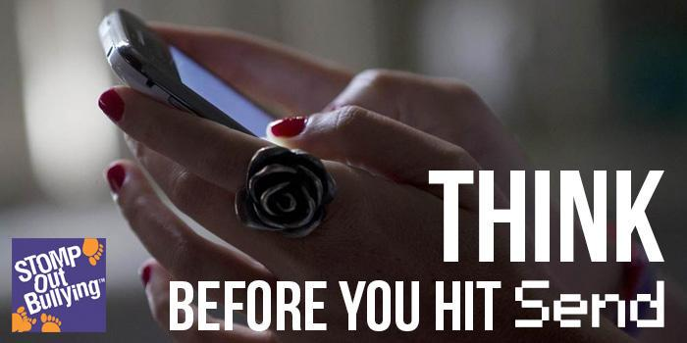
- Instant Messaging/Text Messaging Harassment
- Sending hateful or threatening messages to other kids
- Kids send death threats using IM, text-messaging, photos and videos
- Kids gang up on their victim in text wars or text attacks. They send hundreds or thousands of text-messages to the victim's cell phone or other mobile device, resulting in a large cell phone bill and angry parents.
- Texting or Warning Wars kicks someone else offline for an extended period because ISP's offer a way of "telling on" a user who uses the Internet for inappropriate behavior, remarks and language.
- A kid may create a screen name that is very similar to another kid's name but add or remove an extra vowel. Then they use this name to say disparaging things to other users while posing as the other person.

Web Sites
Kids can create Web sites that could humiliate or endanger another kid. They post photos, videos and all kinds of personal information (such as phone numbers, address, etc.) which could endanger the kid who is the victim.
Sending Pictures through E-mail and Cell Phones
Cell phones allow kids to send pictures to each other. Generally these aren't just regular photos. They are embarassing photos and nude photos which can end up in everyone's address book. Sending nude photos is called sexting
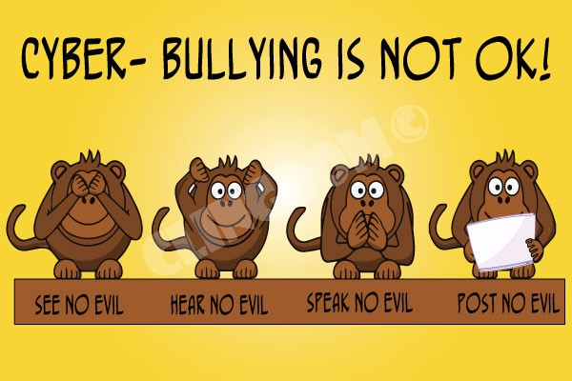
Internet Polling
A perfect way for kids to create more rumor! Asking Who's a Slut? Who's Not? And kids poll to answer.
Interactive Gaming
Games like X Box Live and Sony Play Station 2 Network allow your kids to communicate by chat and live Internet phone with anyone they find themselves matched with in a game online. Sometimes the kids verbally abuse the other kids, using threats and lewd language. Sometimes they take it further, by locking them out of games, passing false rumors about them or hacking into their accounts.
If you think kids couldn't possibly be this cruel -- think again! It happens all the time. Some reports of Cyberbullies are as young as 7 or 8 years-old.
Parents Should:
Be aware ... get involved! As mentioned earlier -- Speak The Lingo and Know The Game!
While there is no one solution, learn everything about the Internet and what your kids are doing online. Parent and schools must address Cyberbullying, as much as they must address face to face bullying. Schools can be effective in partnering with parents to stop and solve Cyberbullying problems. Students should be taught in school about cyberethics and the law. To avoid law suits, schools should make an addendum to their acceptable use policy, and reserve the right to discipline students for actions taken off-campus if they are intended to have an effect on a student or they adversely affect the safety and well-being of student while in school. Then it is no longer a constitutional issue. Most kids won't even tell their parents about a Cyberbullying incident because they're afraid it will make everything worse.
Parents should Google your child's name and see if there is anything being said about your child on the Internet. You can also create a Google Alert with your child's name so that everytime something is said about your child you will receive an email.
Victim's parents should be supportive of their child. Parents may be tempted to tell their kids to toughen up, that names never hurt anybody, yet – cyber attacks can harm a child easily and have a long lasting effect. Millions of cyber accomplices can help target or humiliate your child. That emotional pain is very serious and very real! Do not ignore it!
Alert the school and guidance counselor to watch out for in-school bullying and see how your child is handling things. It is important that you give your child love, support, nurturing and security. Children have committed suicide after having been Cyberbullied. Take it seriously!
You should immediately contact your local law enforcement agency (not the FBI) if you have any knowledge that personal contact information has been posted online, or any threats have been made to your child.
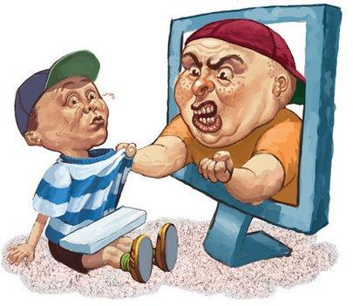
SAVE all proof of the cyberbullying. Save in an email folder, in your favorites if it involves a web site and print everything out.
Although print-outs are not sufficient evidence of proof of Cyberbullying, you should bring a print-out of all instances to show them. You will need electronic evidence and live data for proof.
Educating kids about the consequences helps -- especially if they know they could lose their ISP and IM accounts.
Cyberbullying is a crime in some states. It's also a crime to publish something that is “libelous” – meaning writing something insulting or something that could harm someone's reputation.
Most Internet Service Providers (ISPs) have Acceptable Use Policies (AUPs) that define privileges and guidelines for users and the actions that can be taken for violated guidelines.
ISPs and cell phone service providers can help clients track down the appropriate service provider in response to Cyber Bullying.
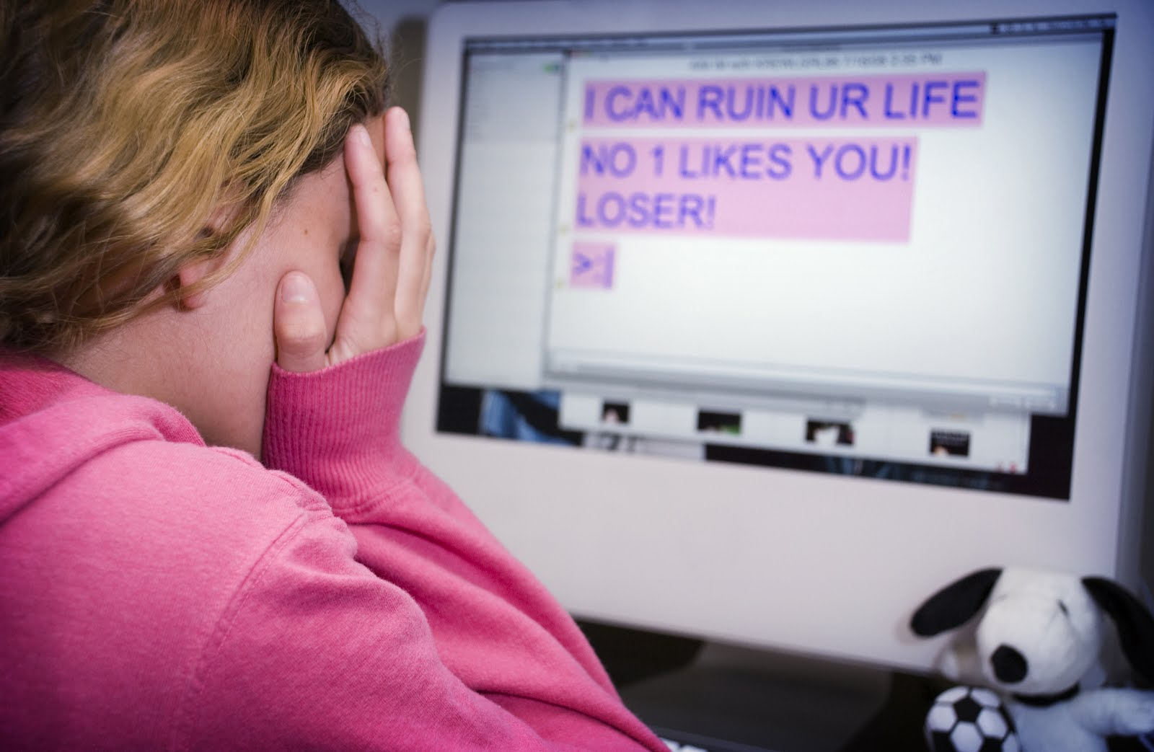
If Your Child is a Cyberbully
According to the Electronic Communications Privacy Act, law enforcement can get your information. The parents of Cyberbullies may be liable for the mental health and emotional damages caused by their child to another child. If the cyberbullies parents is aware of the situation or has received a letter of complaint, then they have “knowledge and notice” of harmful activity. By paying for the telephone bill and internet charges in their home – they are legally responsible for the acts of their children while on the computer and in their care. Parents can be sued for damages.
School administrators should be informed about the cyberbullying which your child is a victim of. If cyberbullying takes place during school time or on school computers, the schools come under the “knowledge and notice” rule.
If a victim of cyberbullying is being threatened with assault or being beaten up or beaten down while they are in school, the schools must take responsibility for activities that follow a child from their home to their school.
We must insist on NO TOLERANCE of any bullying -- whether it's face to face or through technology. By teaching kids kindness, compassion and respect and why it's important, we can stop all forms of bullying.
Teach kids to speak out against bullies. Teach them that by keeping silent about their knowledge of Cyberbullying against other kids is not acceptable.
Teach your child how important it is to immediately tell you or the school if they see communications in which another teenager is threatening violence or suicide.
Encourage your child to be part of the solution against all forms of bullying!
Kids who report cyber bullying may be saving someone’s life!
Signs of your child being Cyberbullied:
- Depression
- Anxiety
- Anger or Fear
- Not wanting to go to school
- Changes in their grades
- Avoiding friends
- Hesitation to use their computer
If the Cyberbullying becomes serious and won't stop:
- Contact the police
- Contact an attorney or file a small claims action - Civil law provides for victims to sue a bully or the bully’s parents to recover damages.
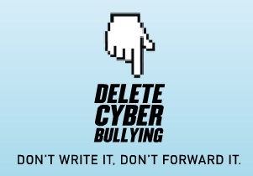
Kids Who Are Being Cyberbullied Should:
- Don't do anything. Take a deep breath and calm down.
- Block the cyberbully or limit all communications to those on your buddy list.
- Save the harassing messages and forward them to your ISP.
- Tell a trusted adult!
There is help, there is hope --- all you need to do is be brave, be smart and be proactive!
- Some kids have actually posted pornographic pictures on sites and programs for anyone to download. This is against the law. In some states your child could become a registered sex offender.
- Sending explicit messages or photos photos electronically is considered sexting -- (a combination of sex and texting). This is primarily done between cell phones. It shows poor judgment when using digital technology by sending an image, video or text message of an explicit (adult) or risque nature to another individual. This is against the law and could result in arrest in some states.
E-mails like these get passed around to hundreds of others -- going viral and ending up everywhere in cyberspace.
Impersonation
Posing as the victim, Cyberbullies may post erotic or suggestive messages in a hate group's chatroom posing as the victim -- inviting an attack against them. They give the name, address and phone number of the victim to make the hate group's job easier. They might even send a message to someone posing as the victim, saying hateful or threatening things while masquerading as the victim. And they often alter a message actually from the victim, making it seem that they have said something horrible.
Sending Malicious Code
Kids can send viruses, spyware and hacking programs to their victims to destroy their computers or spy on their victim. If the Cyberbully uses a Trojan Horse program they can control their victim's computer remote control, and erase the hard drive.
Sending Porn and Other Junk E-Mail and IMs
Cyberbullies may sign their victims up for numerous e-mailing and IM marketing lists which creates mass emails for the victim. They even sign them up for porn sites.
Blogs
These online journals are a way for kids to damage other kids' reputations or invade their privacy. Sometimes kids set up a blog or profile page pretending to be their victim and saying things to humiliate them.
Stealing Passwords
- Kids can steal the password and lock the victim out of their own account.
- Kids may use another kid's password to change his/her profile and write sexual, racist and disparaging remarks about that person.
- Kids may steal another kid's password and chat with others pretending to be the other kid. They can say mean things to this person's friends or other people.
- Kids can give or sell the password to a hacker to hack into the victim's computer.

